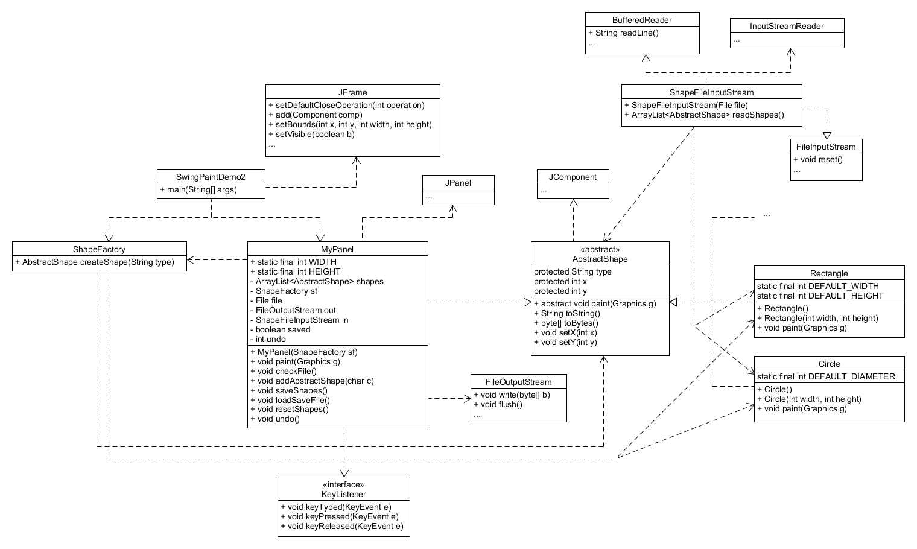1.

The SwingPaintDemo2 class runs the app. It creates a JFrame which contains the MyPanel object. Before adding MyPanel to the JFrame, MyPanel is constructed with a ShapeFactory object. This ShapeFactory has a createShape method which can be easily expanded to handle new shapes. Currently, it only handles creating a Rectangle and Circle. The MyPanel object creates one KeyListener in its constructor. All of the KeyEvents are handled by this KeyListener. When a recognized KeyEvent occurs, other methods within the MyPanel class are called in order to perform the desired action. For instance, the undo() method is called when the U key is pressed. To save the current state of the GUI, a FileOutputStream writes each AbstractShape’s type (e.g. circle, rectangle), x-coordinate, and y-coordinate to a text file. To read the text file, a ShapeFileInputStream object processes the text line by line, creating the corresponding shape at its given coordinates. It then returns an ArrayList of the AbstractShapes to MyPanel where all of the shapes can be drawn.

The design pattern that I implemented is the Factory Pattern. I utilize a Factory object (ShapeFactory) to handle the majority of my shape creation.